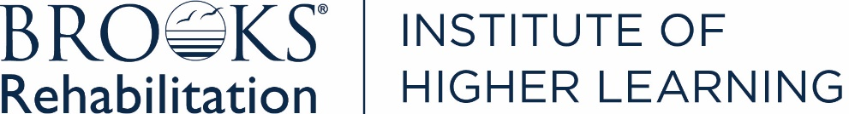

Brooks Rehabilitation Orthopaedic Manual Physical Therapy Fellowship Curriculum

Curriculum Overview:
- Our program is 2 years in length with a cohort of 1st year and 2nd year Fellows-in-Training (FiTs) interacting throughout the program.
- Class will meet on most Wednesdays from 8:00am-5:00pm and several weekend days 8:00am-5:00pm for continuing education courses that are integrated into the curriculum.
- Fellows in Training (FiT) will receive 150 hours of 1:1 mentoring from an AAOMPT Fellow while treating their own caseload.
- Curriculum within the classroom component is divided into two types of learning:
  - Theoretical/Cognitive classwork (402.5 hours)
  - OMPT Psychomotor Training (201 hours assessment and intervention techniques)
    - 132 spine and 69 extremity dedicated hours
    - 28 hours related to practical assessments.
- The different aspects of learning (i.e. Theoretical/Cognitive & Psychomotor) will be integrated within each component of the curriculum as well as within the clinical mentoring.
- Each FiT will participate in Directed Learning Activities (DLAs) within the areas of clinical practice, education, scholarly activities, professionalism, and practice management. This includes providing 1:1 clinical mentoring for Orthopaedic Residents and participation in a research project.
- FiTs will practice full time, typically 32-40 hours per week over four days, and will be given 120 hours of “banked time” to use each year to complete OMPT Fellowship program requirements.
  - 20 of those hours to be used towards an elective DLA track of the FiT’s choice in the 2nd year.

- A series of classes per body region makes up most of the weekday curriculum
  - Upper Extremity, Upper Spine, Lower Spine, Lower Extremity
- There are two general types of classes:
- 1. Didactic Presentations and Combined Theoretical/Cognitive
    - Didactic Presentation Classes include presentations developed and presented by the first-year FiTs
      - The presentations range from 2-4 hours in length
- 2. Psychomotor Lab classes
    - Theoretical/Cognitive & Psychomotor Labs
      - Each FiT will present >/1 patient case with Clinical Reasoning Discussion
        - Practical work related to the patient cases to follow (FiT and/or Coordinator led)
      - Each FiT will serve as the leader for designated psychomotor lab components
      - Fellowship Coordinator leads psychomotor lab components for advanced manual techniques including HVLA thrust manipulation and other skills as indicated
      - Fellowship Coordinator integrates educational strategies as indicated to advance
the FiTs’ ability to synthesize and evaluate data for best patient management in an evidence informed manner

  - Typical Class Schedule per Body Region
    - 1st Year
      - Didactic Presentation class
      - Theoretical/Cognitive & Psychomotor Lab day with only FiTs 1 present
      - Theoretical/Cognitive & Psychomotor Lab day with both FiTs 1 and 2 present
    - 2nd Year
      - Theoretical/Cognitive & Psychomotor Lab day with only FiTs 2 present
      - Theoretical/Cognitive & Psychomotor Lab day with both FiTs 1 and 2 present
- Each FiT will serve as the leader for psychomotor practice sessions as assigned (to occur outside of designated Wednesday or Weekend class times). These sessions will be scheduled and coordinated by the FiTs. The Faculty may or may not be present for these sessions.
  - 4 hours per joint/region for a total of 44 hours
- Each FiT will undergo formative and summative assessment throughout the program.

Program Overview:
Psychomotor Training 201 Hours
Theoretical/Cognitive 638 Hours (219 hours from in-person class & 419 hours from DLAs)
1:1 Clinical Mentoring 150 Hours

Total Educational Hours 839+ Hours (as some DLAs are not assigned hours)
Total Patient Care Hours 3000-3600 Hours Total Program Hours 3989-4489 Hours

Revised 11/2025

